Game Rules

Game 1 (Restaurant):

Game objective is to make as much dishes as you can in a limited amount of time. You can choose difficulty for each dish you are making. After that you will have tasks that you need to complete in order to finish dishes. In order to complete your dishes you will have to cooperate with your oponents. During the game you will notice that might luck some products or kitchen arsenal. In order to fill that you have to write a note to your oponents asking for product and the one who gives you that gets extra points. After you’ve completed all of the tasks and finished the dish you will ring the bell and put the order on the table to receive your points. When the time runs off, the winner will be the one who got the most points.

Feedback: very nice game and idea but we have to make it so we can play it on the paper.

That’s why we decided to make another game that we would actually be able to make into a working game from paper.

Pictures:

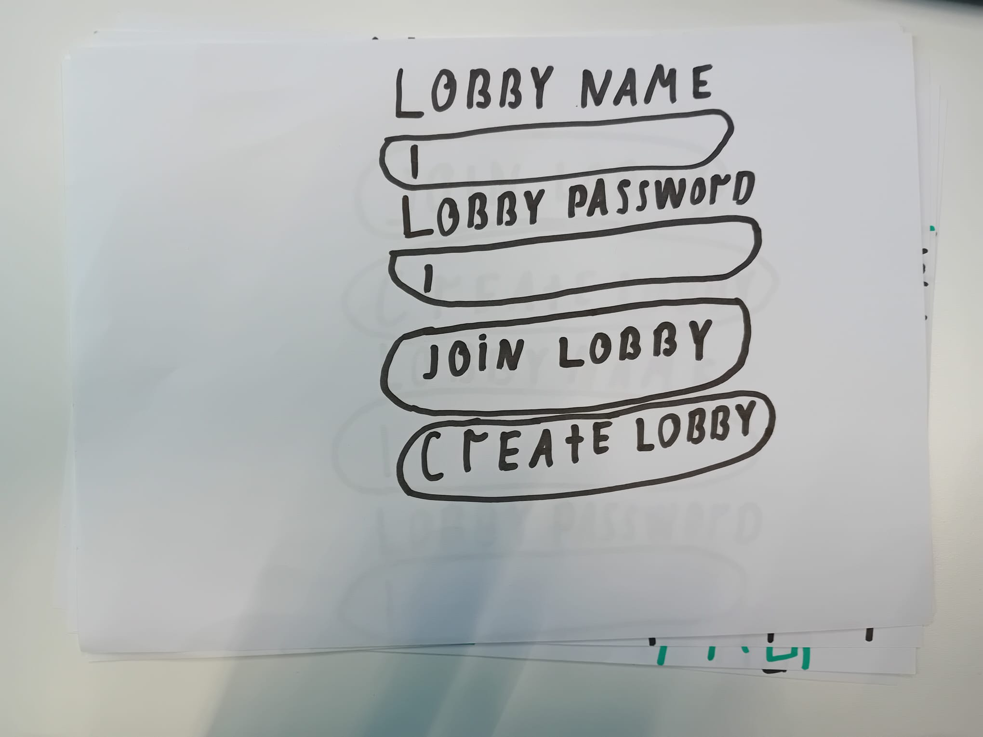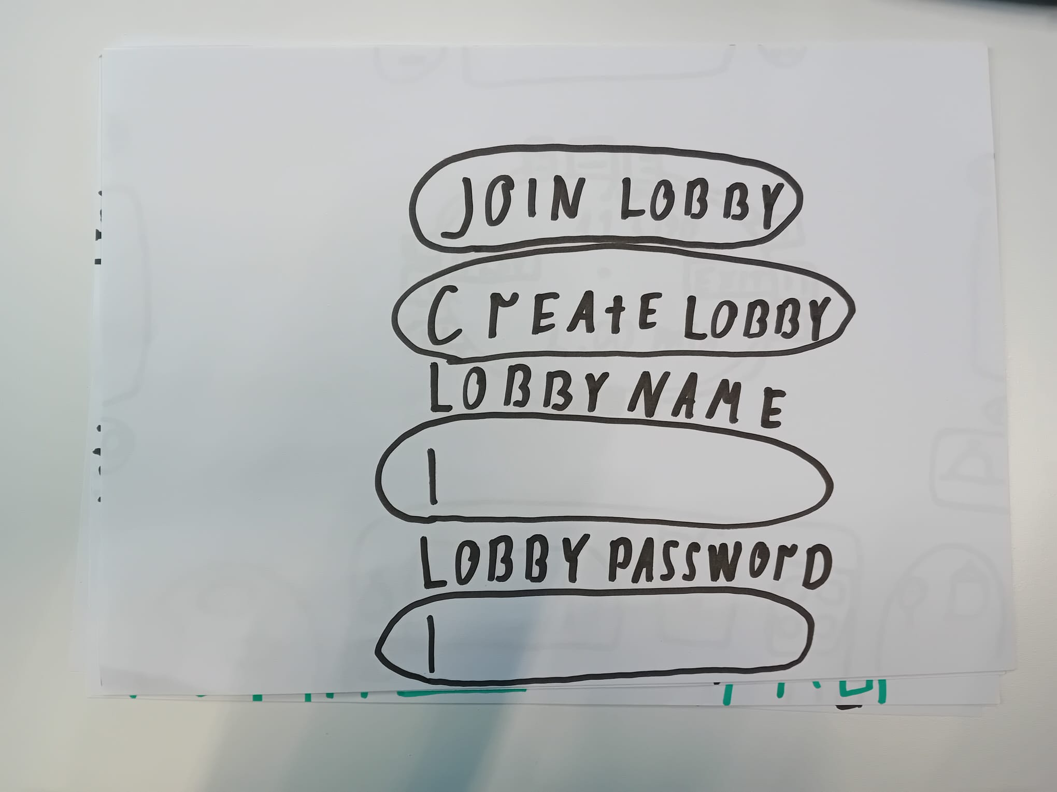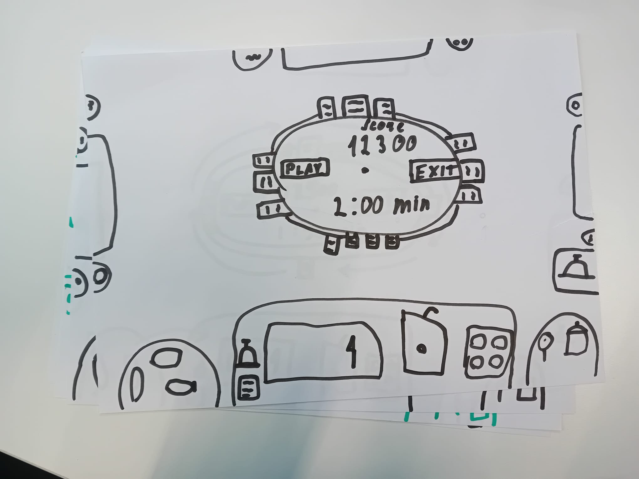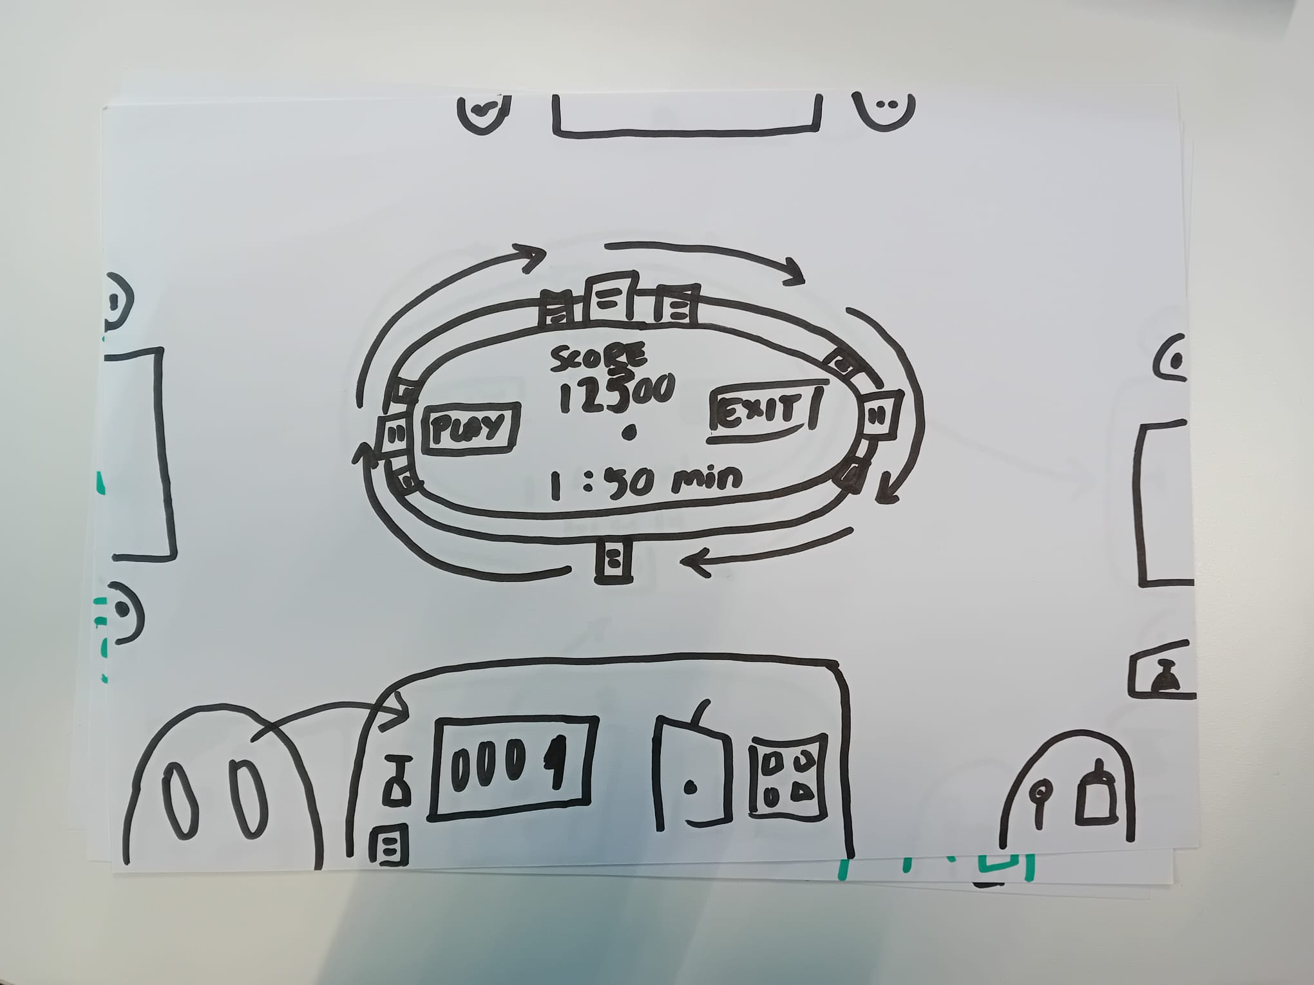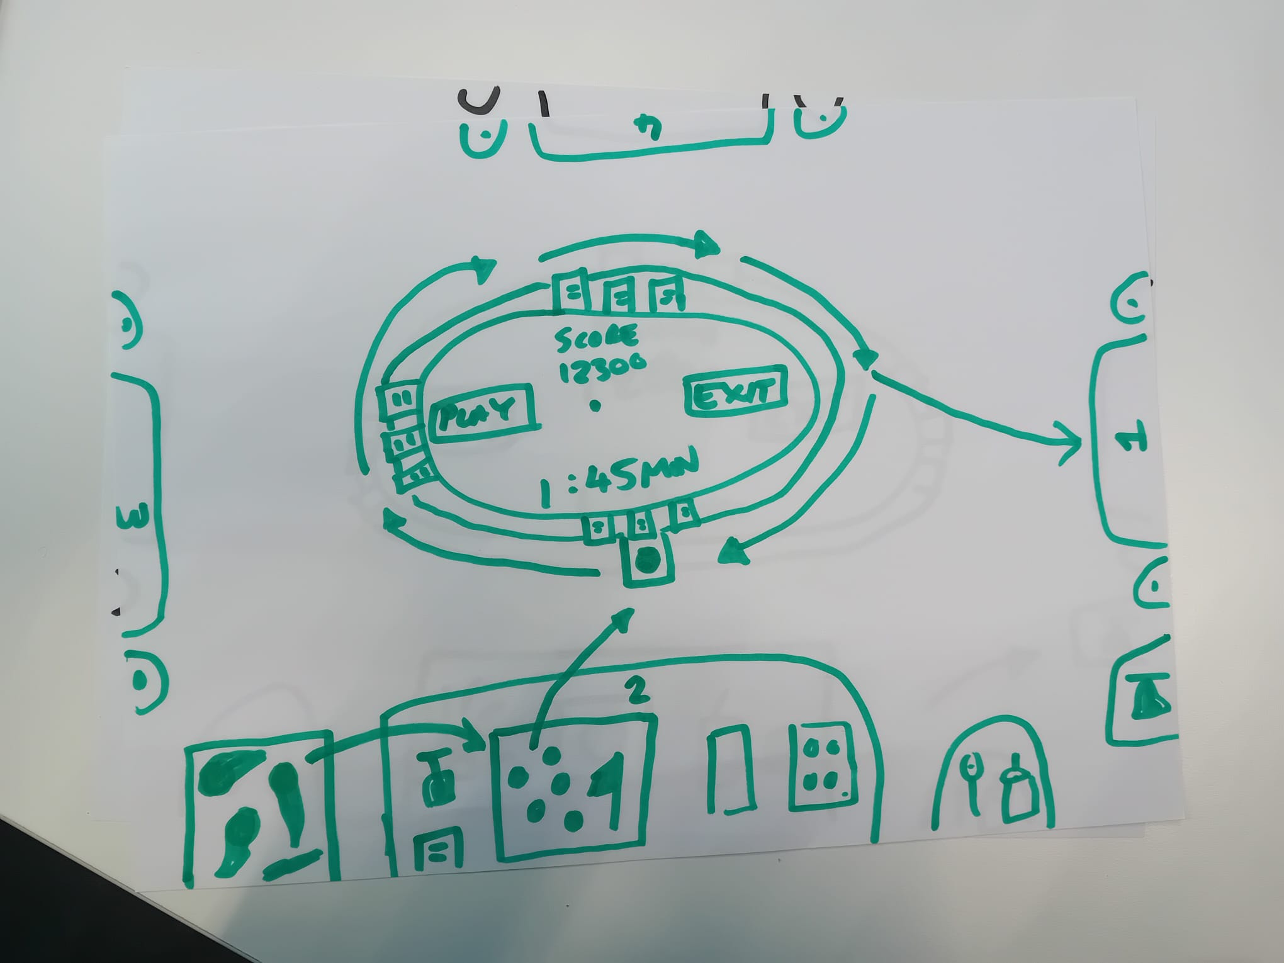

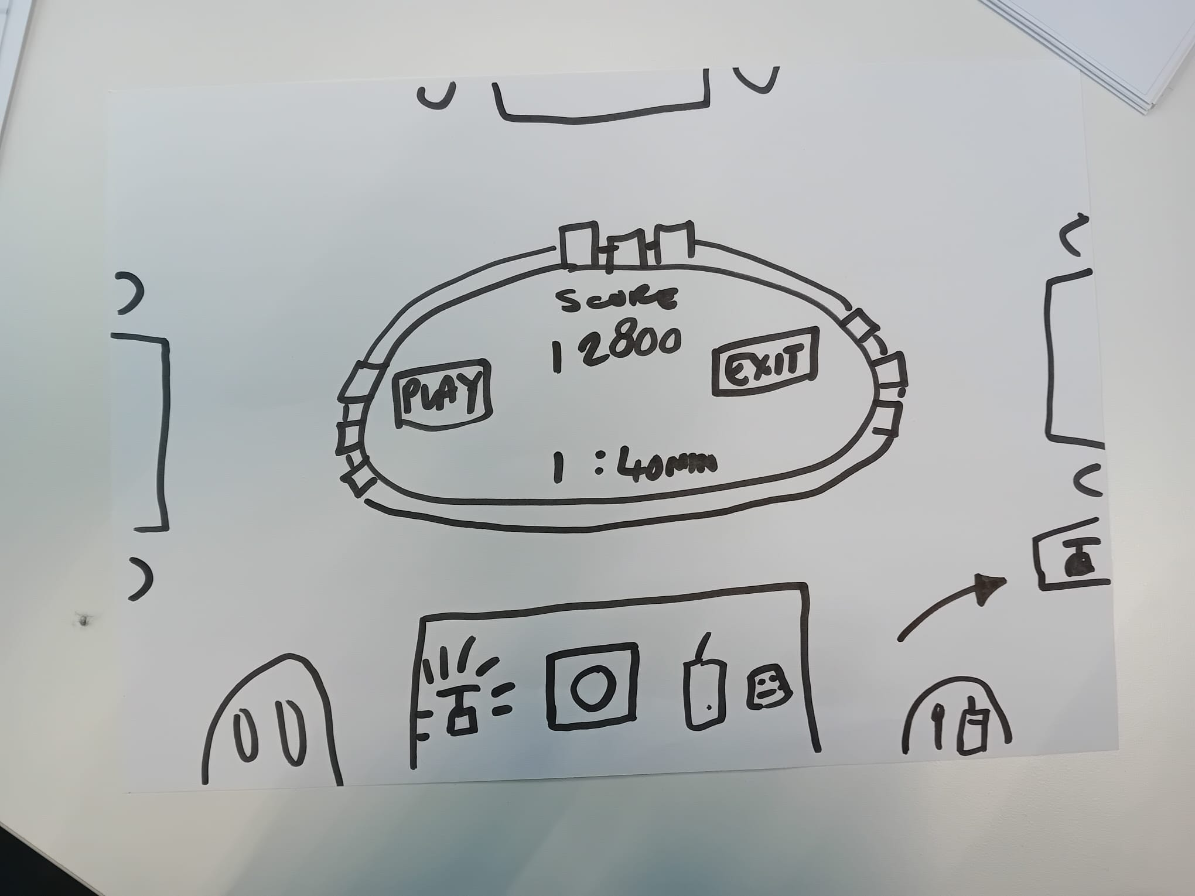

Game 2 (Questionary):

You start the game with taking a paper with the question on it. If you answer the question you can keep the paper indicating that you have a point from it. If you don’t answer it immediately, you can ask for a hint from someone. If you answer using you will get the point as well. But, if not, you will not get a point and you take an answer paper and say it out loud.

Pictures:

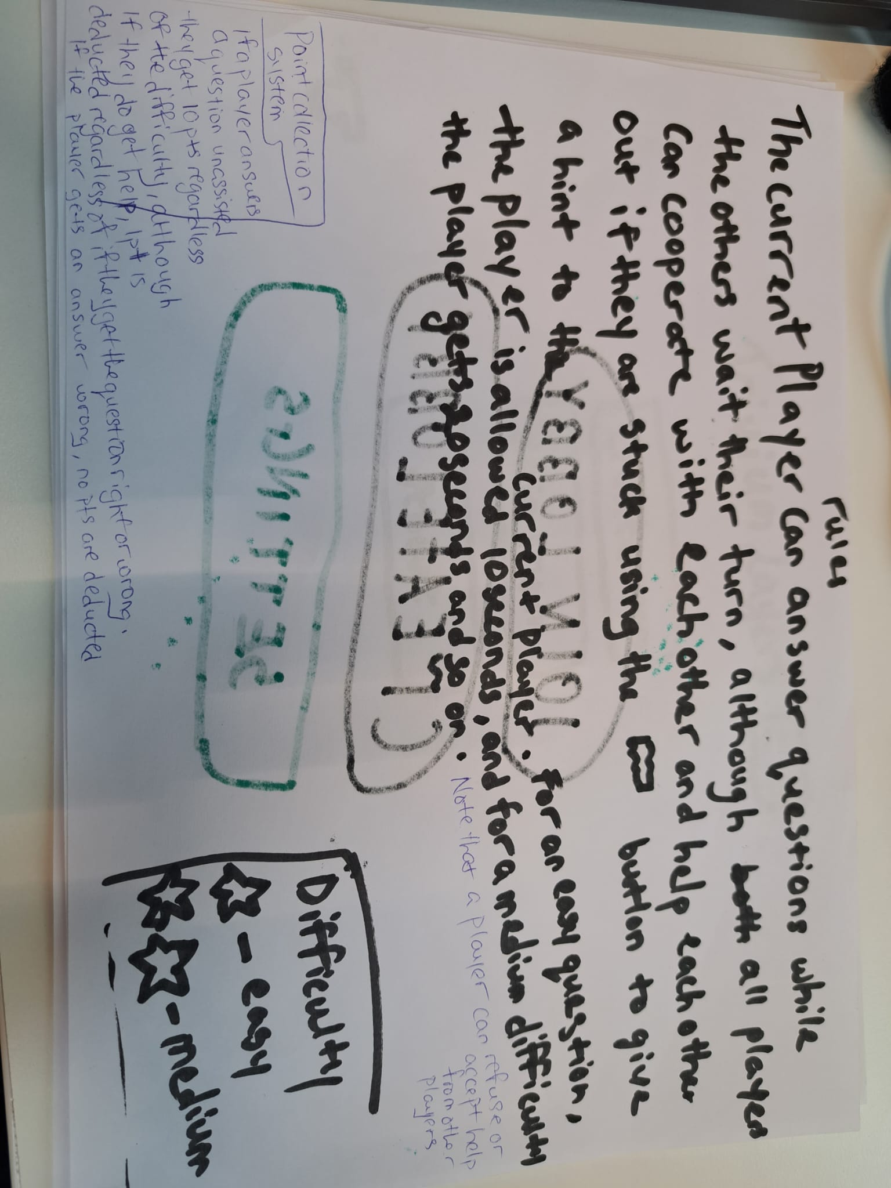

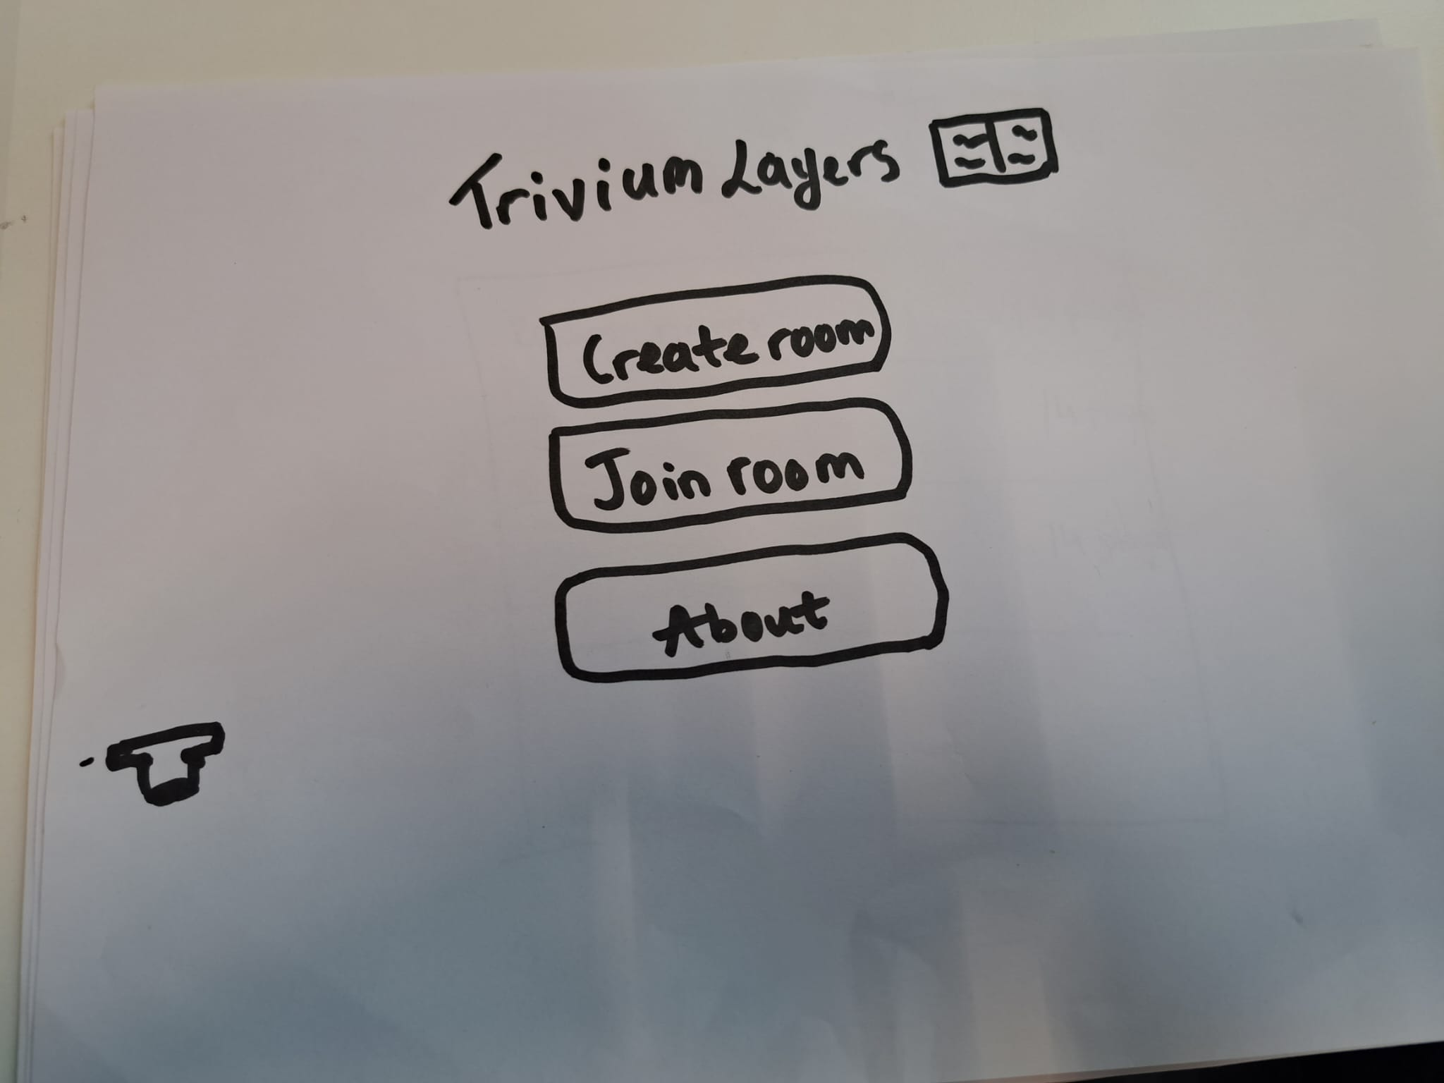

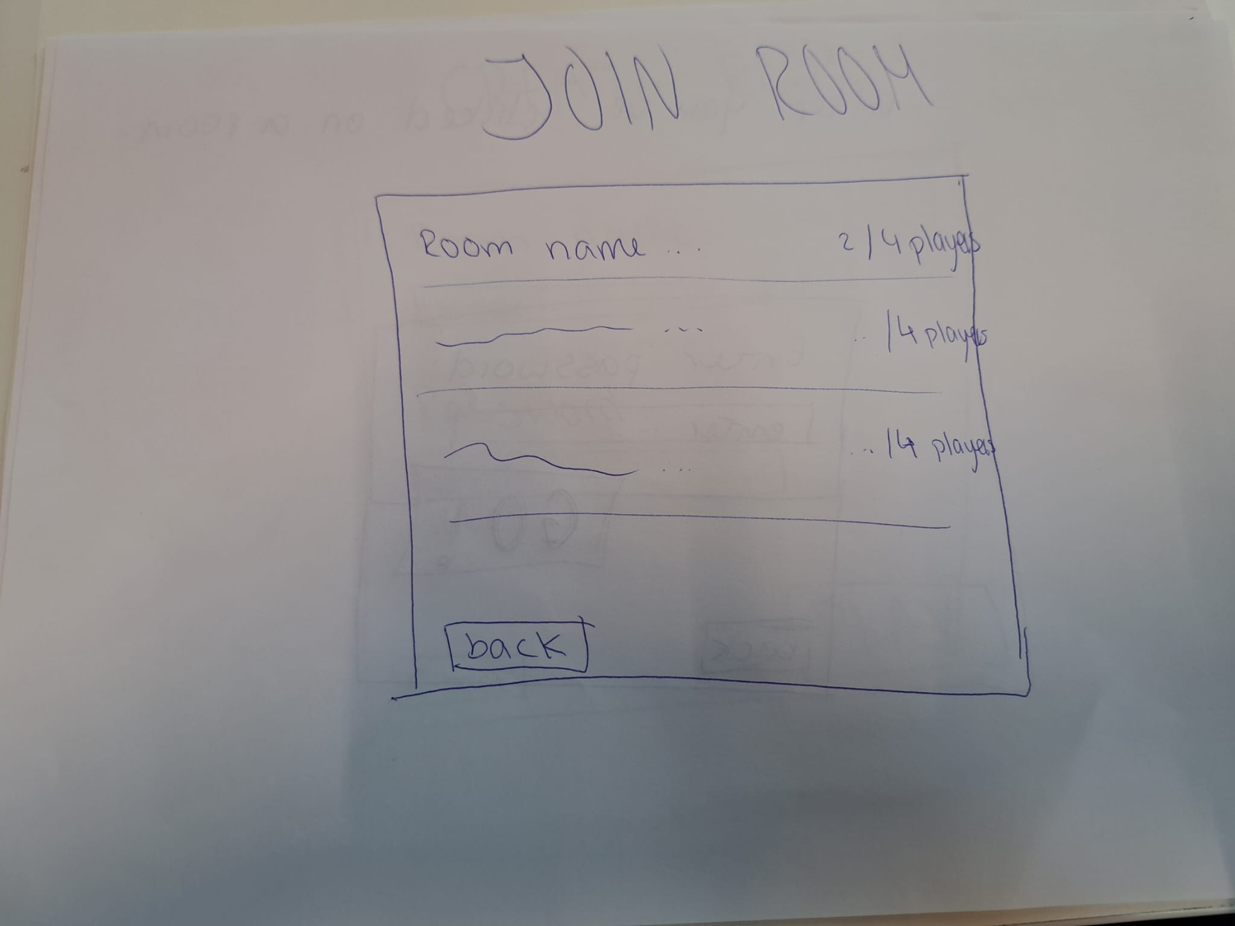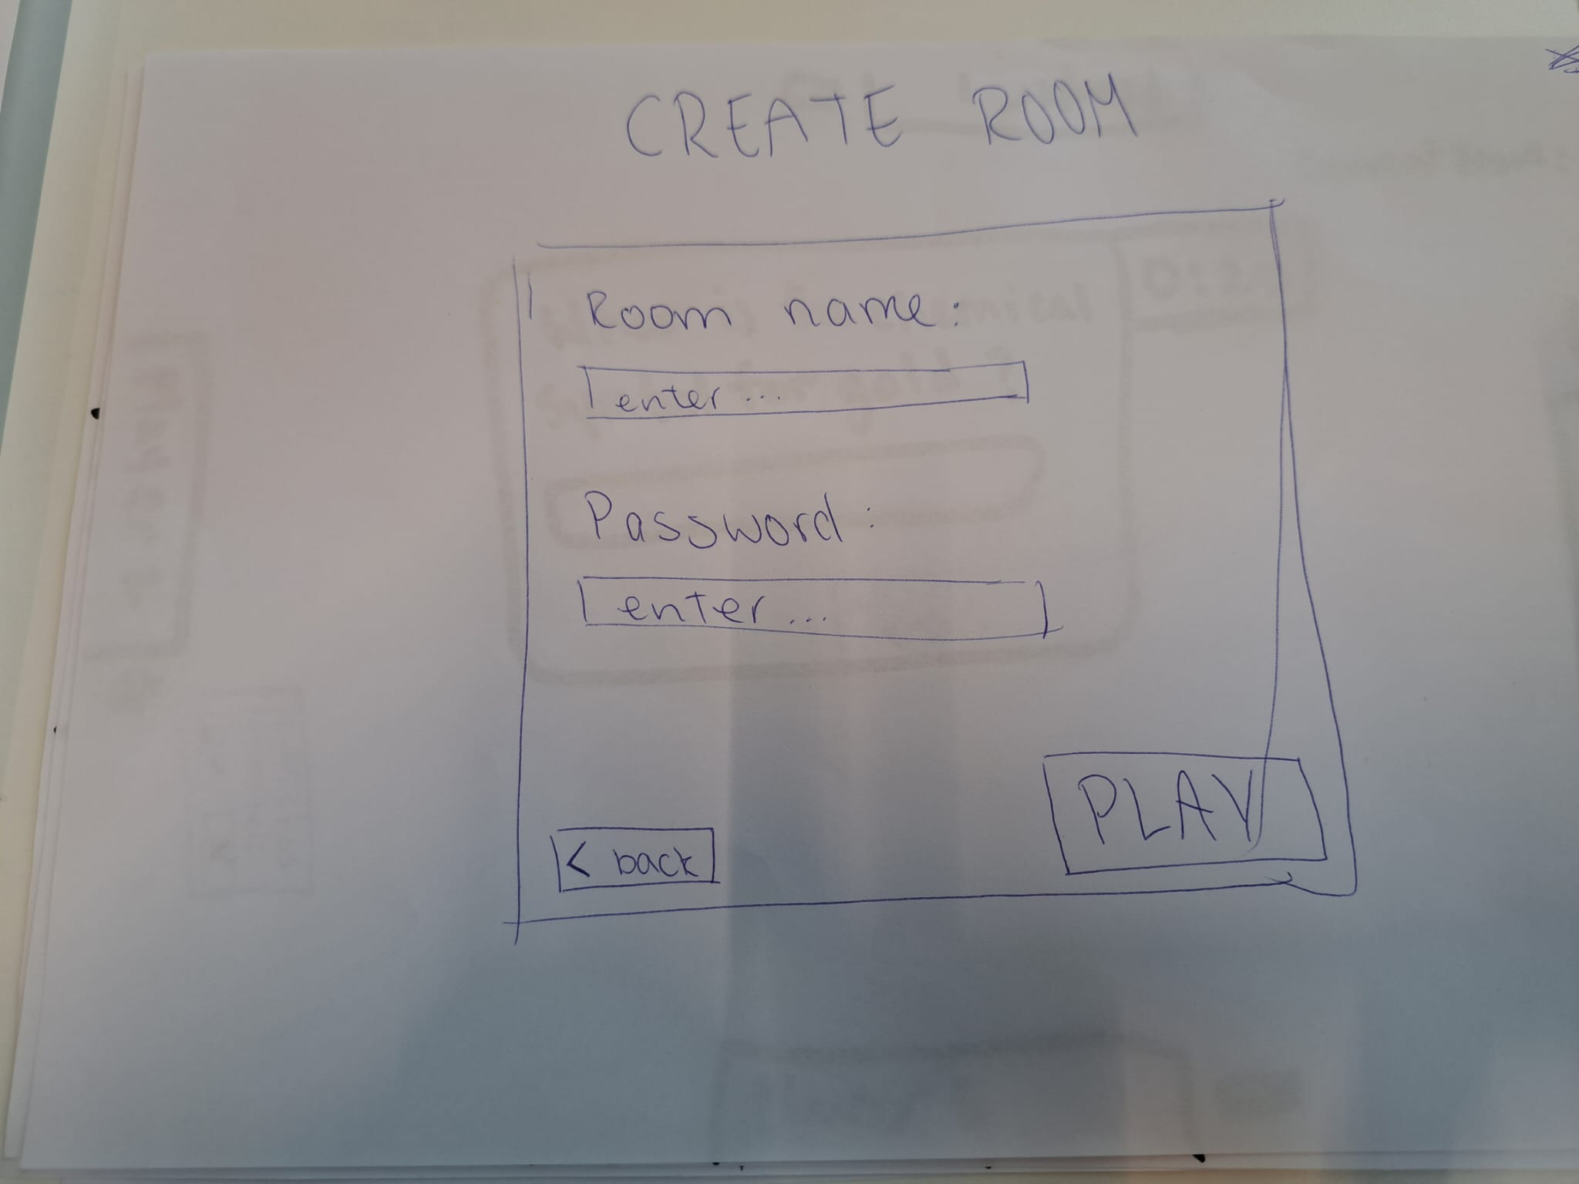

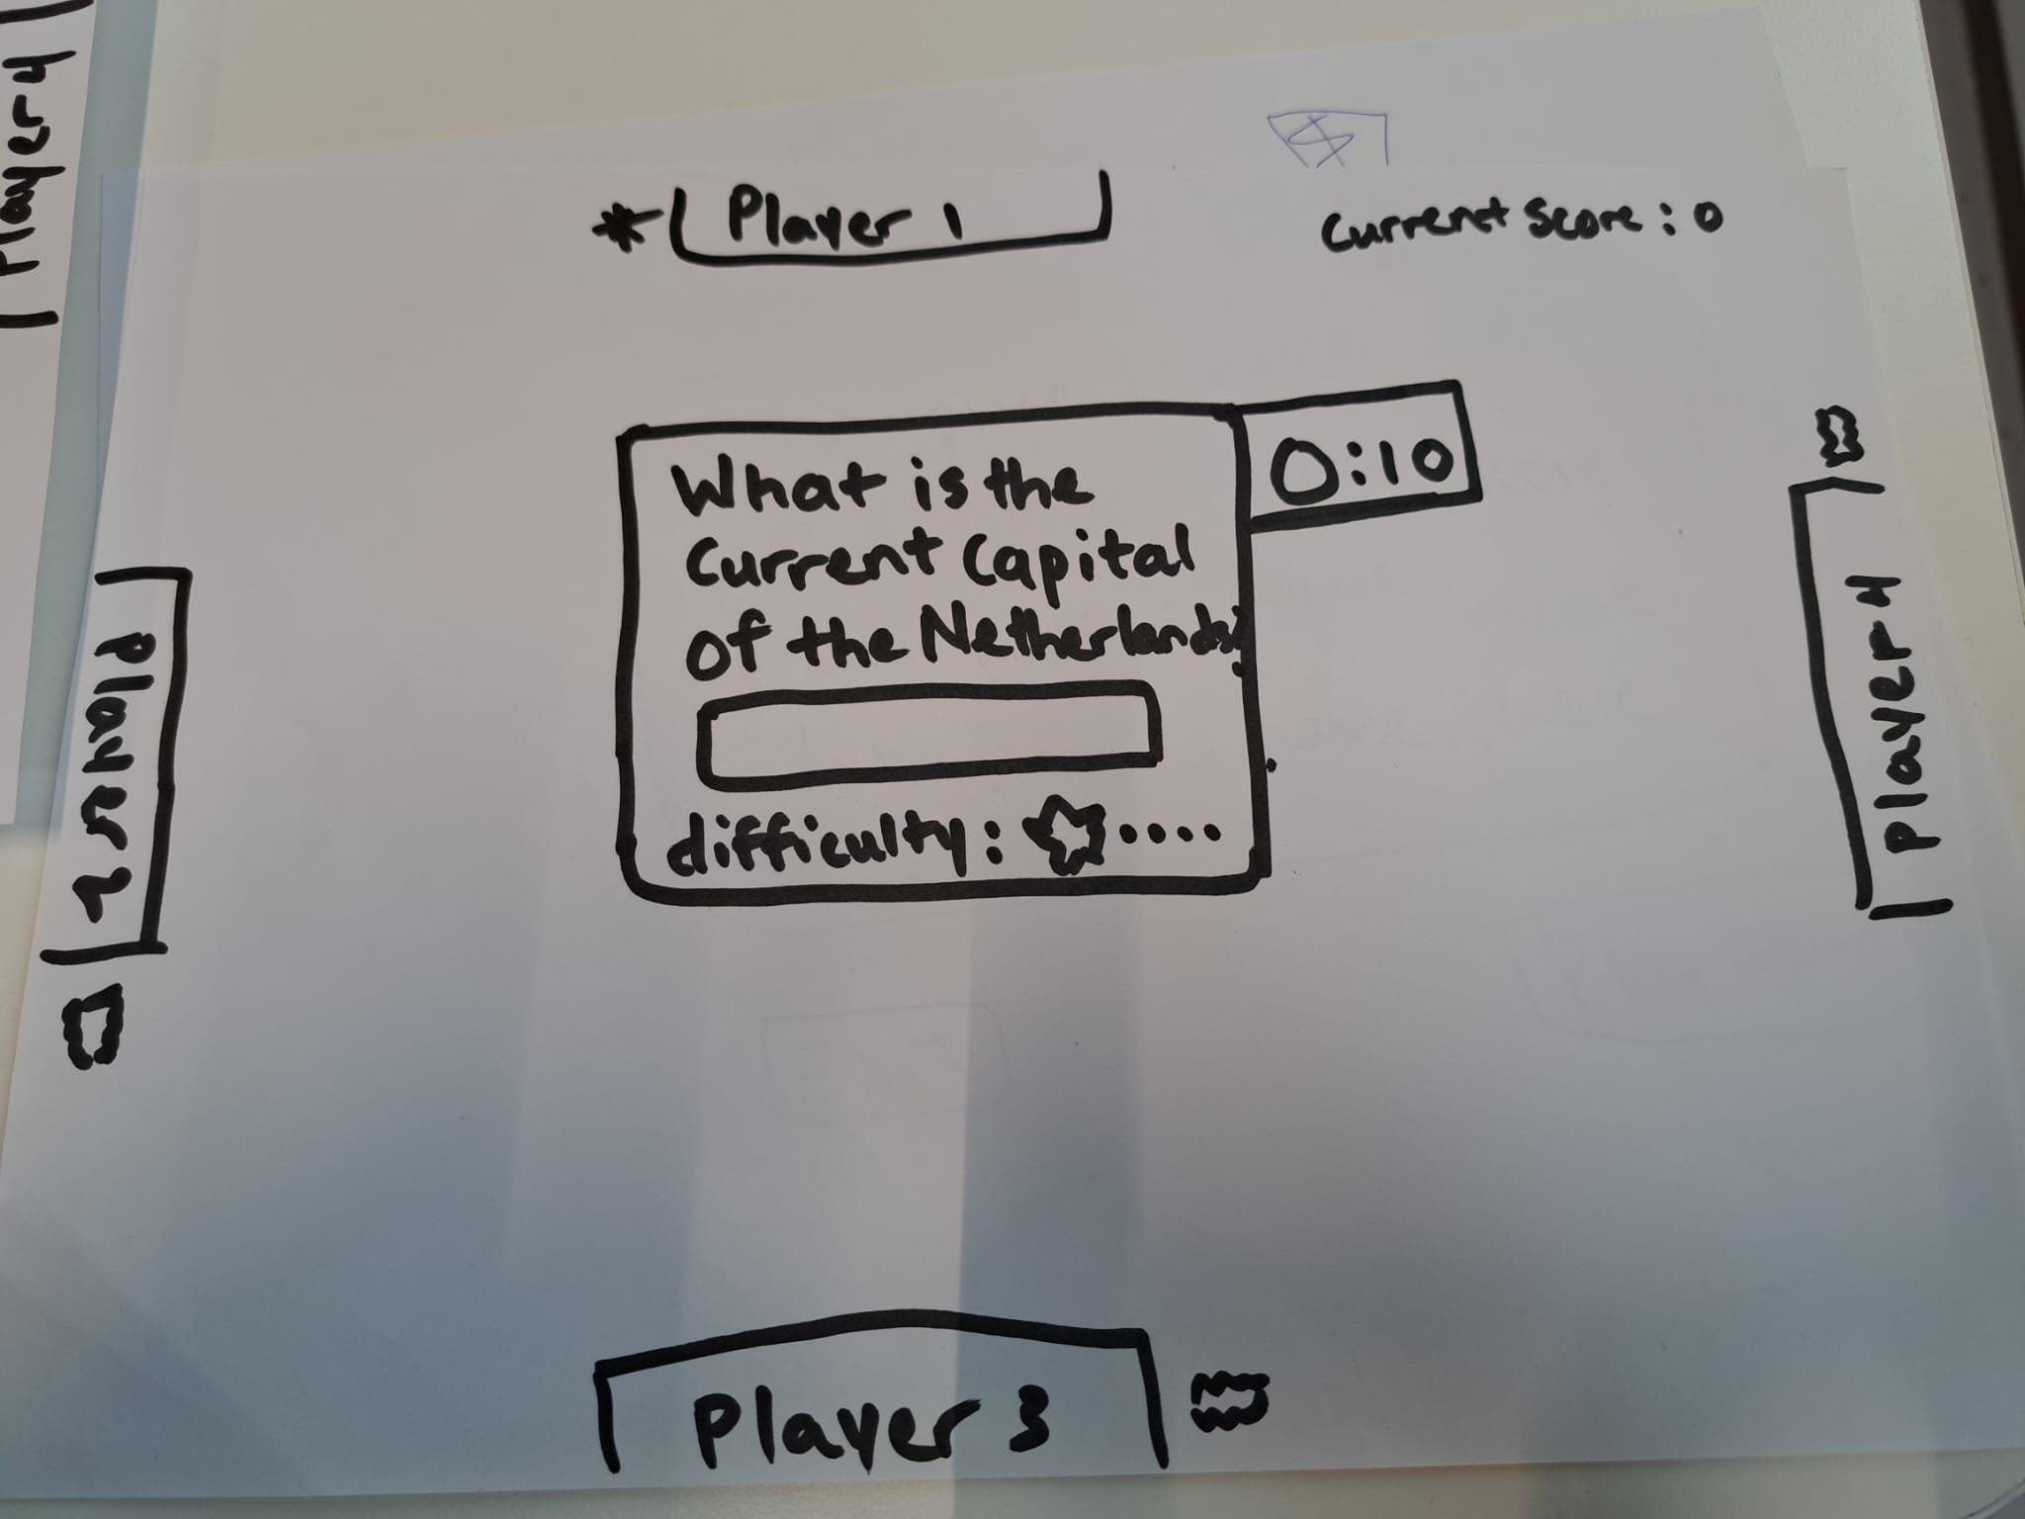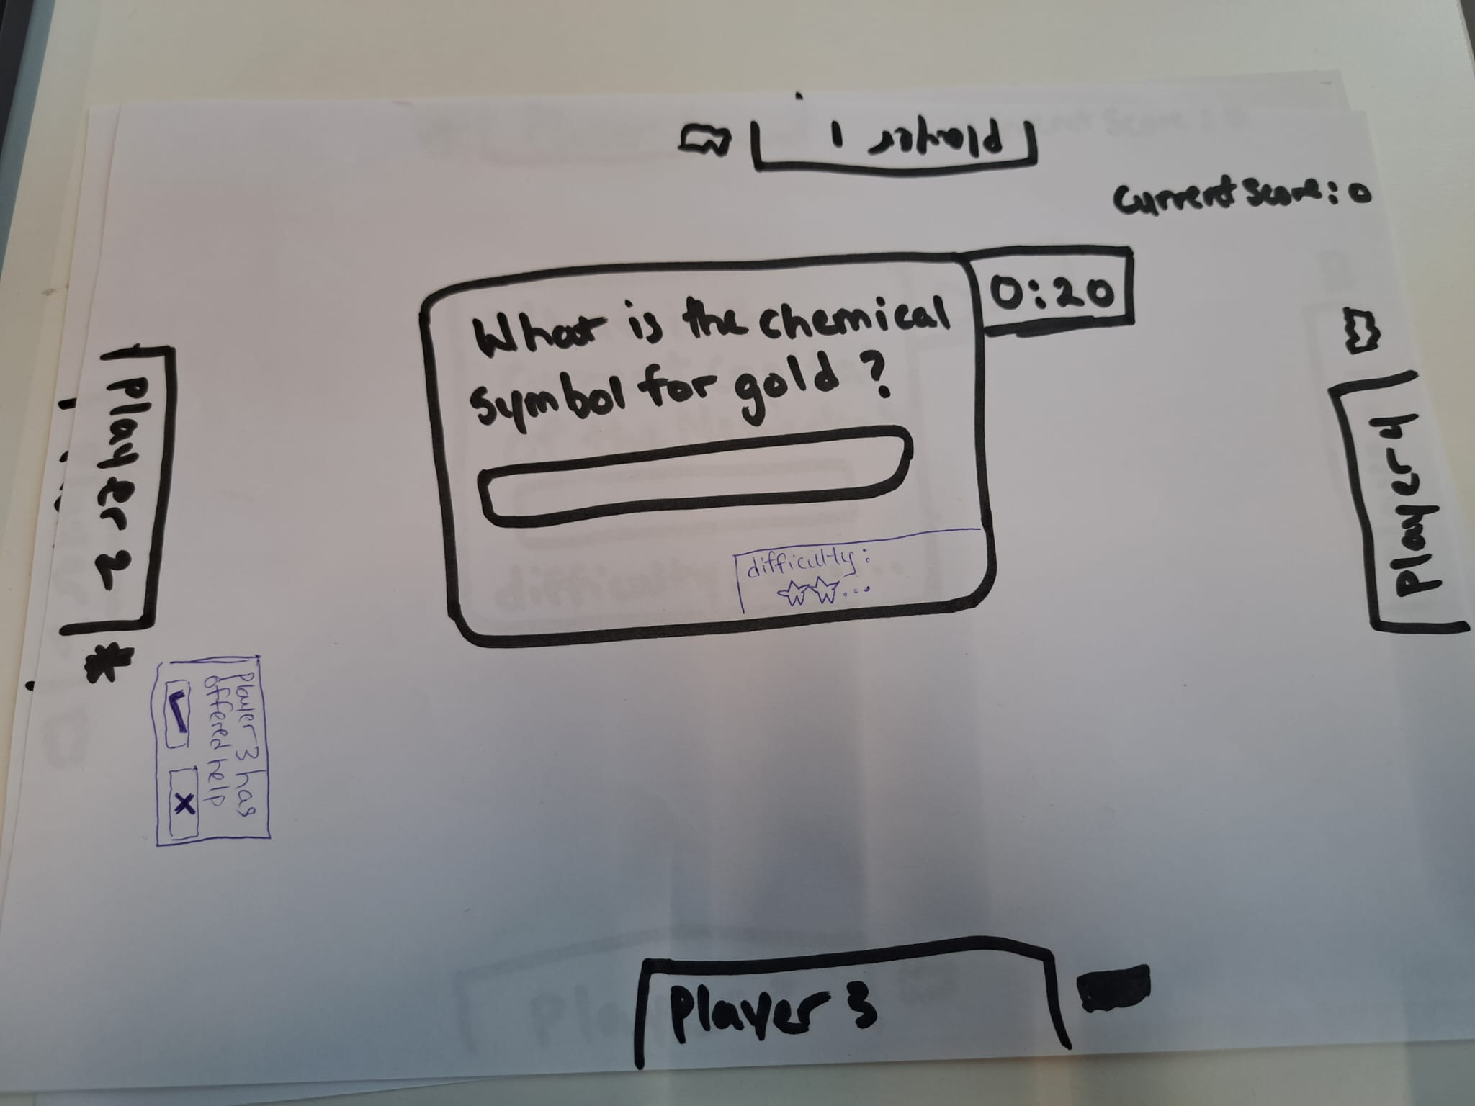

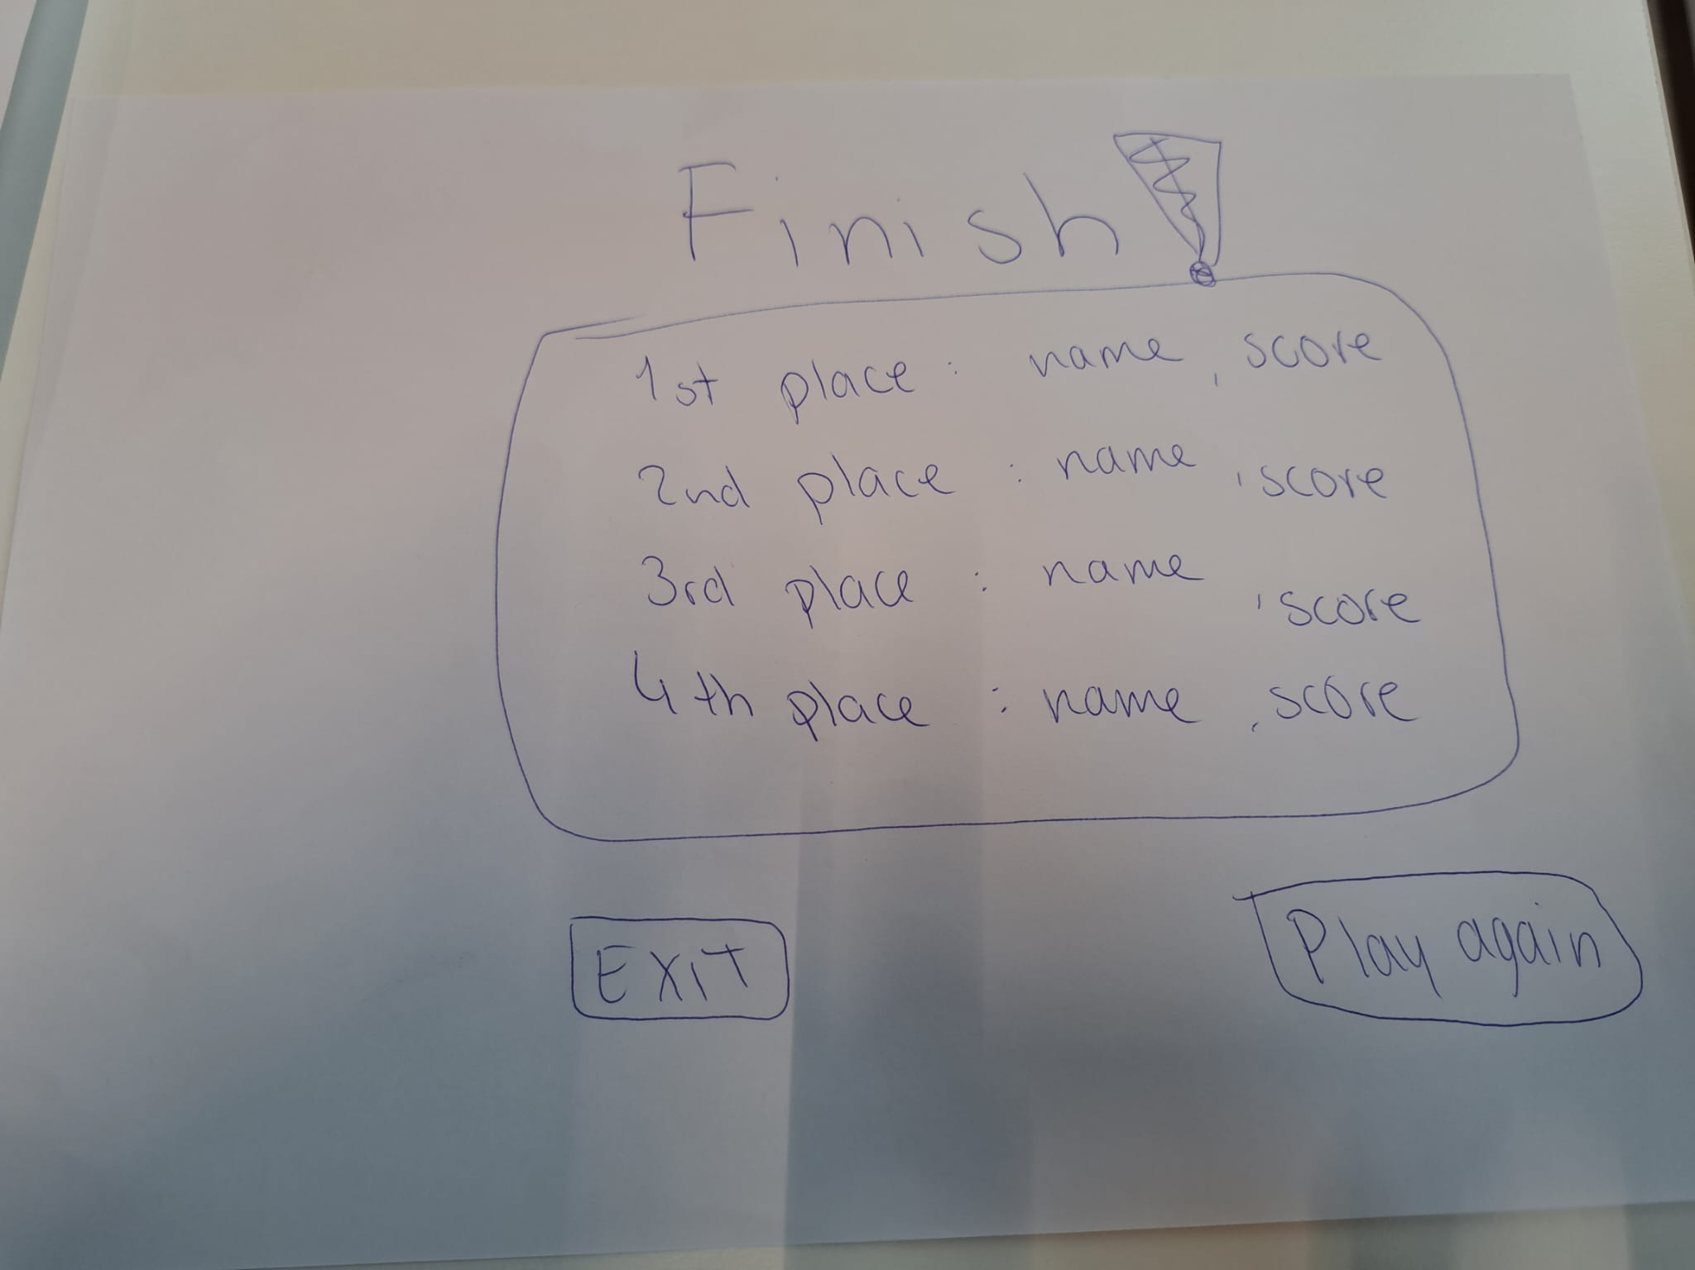

Video Link: “<https://youtu.be/0MKfnP_13i0?si=mSh6Frpr5-jCRA3L>”